COGNIZANT DIGITAL NURTURE 5.0 – DEEPSKILLING
WEEK 1 : Advanced SQL Mandatory Exercises
Submitted By
Name: Lochan Kumar Nayak
Email: lochankumarnayak50@gmail.com
University: C. V. Raman Global University, Odisha
Exercise 1: Create a Stored Procedure
Goal: Create a stored procedure to retrieve employee details by department.
Steps:
1. Define the stored procedure with a parameter for DepartmentID.
2. Write the SQL query to select employee details based on the DepartmentID.
3. Create a stored procedure named `sp_InsertEmployee` with the following code:
CREATE PROCEDURE sp_InsertEmployee
@FirstName VARCHAR(50),
@LastName VARCHAR(50),
@DepartmentID INT,
@Salary DECIMAL(10,2),
@JoinDate DATE
AS
BEGIN
INSERT INTO Employees (FirstName, LastName, DepartmentID, Salary, JoinDate)
VALUES (@FirstName, @LastName, @DepartmentID, @Salary, @JoinDate);
END;
Creation of Table:

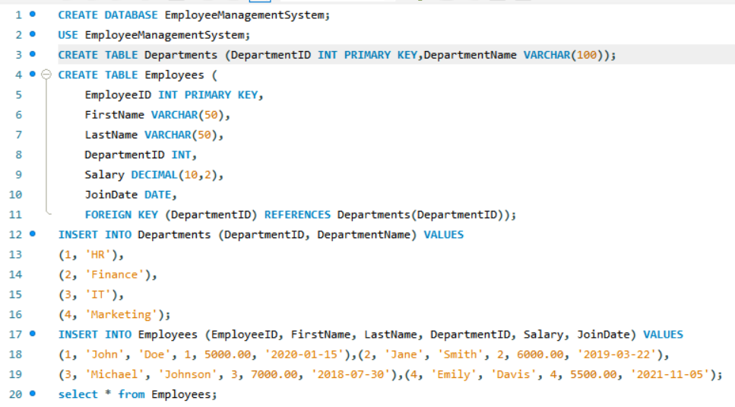
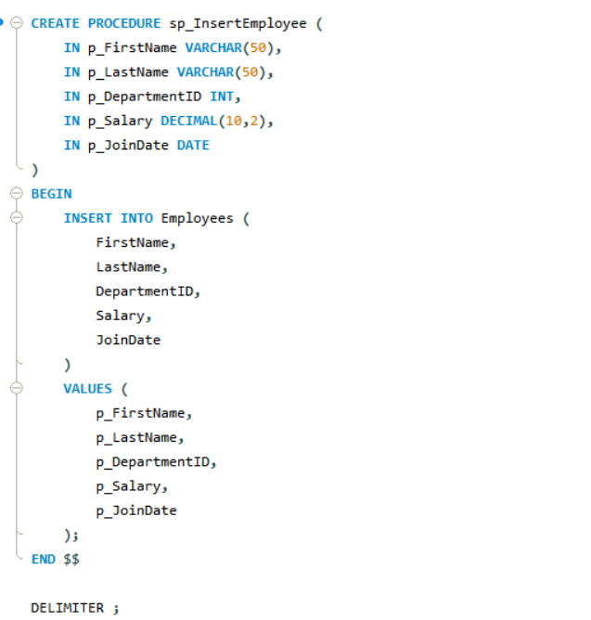

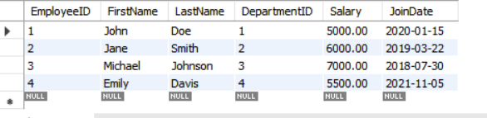

solution for Exercise 1:
1)

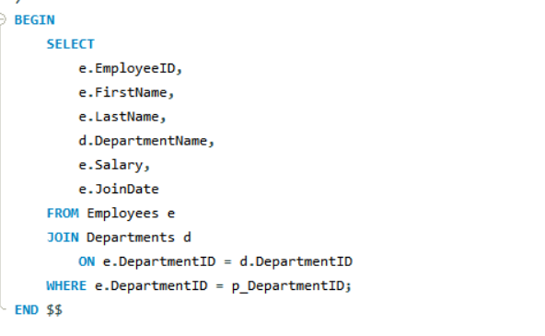

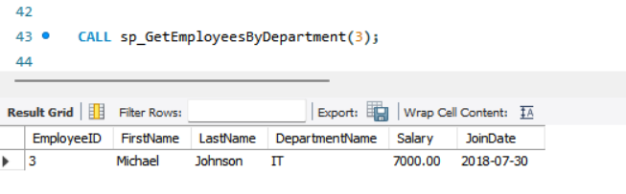
2)

3)
